**Stock Price Prediction**

**Introduction**

* Begin with a powerful quote or statistic related to the financial markets to capture the audience's attention."Warren Buffett once said, 'The stock market is designed to transfer money from the Active to the Patient.' Today, we explore how data-driven stock price prediction can help you become one of the patient investors."
* Explain the relevance of stock markets in people's lives and the profound impact they have on wealth, retirement, and financial stability.
* Describe the purpose and objectives of your presentation.

**DATASET**

Yahoo Finance offers historical stock price data that can be easily downloaded. You can find historical data for most publicly traded companies. Here's how to access it:

* Go to Yahoo Finance (<https://finance.yahoo.com/>).
* Search for a specific stock.
* Click on the "Historical Data" tab.
* You can download the data in CSV format.

**COLUMNS USED**

1. **Historical Price Data**:
   * **Open Price**: The stock's opening price at the beginning of a trading day.
   * **Close Price**: The stock's closing price at the end of a trading day.
   * **High Price**: The highest price reached during a trading day.
   * **Low Price**: The lowest price reached during a trading day.
   * **Volume**: The number of shares traded during a trading day.
2. **Derived Features**:
   * **Price Change**: The difference between the closing price and the opening price.
   * **Price Change Percentage**: The percentage change in price during the day.
   * **Moving Averages**: Simple moving averages (SMA) and exponential moving averages (EMA) over different time periods can be used as features.
   * **Volatility**: Metrics like standard deviation of returns can capture volatility.

**LIBRARIES USED**

1. **Pandas**: For data manipulation, cleaning, and transformation.
2. **Numpy**: Provides support for mathematical and numerical operations.
3. **Scikit-Learn**: Offers a wide range of machine learning algorithms and tools for model building and evaluation.
4. **TensorFlow or PyTorch**: Deep learning frameworks for building and training neural networks.
5. **XGBoost or LightGBM**: Popular gradient boosting libraries for regression and classification tasks.
6. **Statsmodels**: For statistical modeling and time series analysis.
7. **Matplotlib and Seaborn**: Data visualization libraries for plotting stock price data and model results.
8. **Ta-Lib (Technical Analysis Library)**: Provides various technical indicators for financial analysis.
9. **Quandl or Alpha Vantage API**: Used for fetching historical stock price and financial data.
10. **Jupyter Notebook**: An interactive environment for developing, experimenting, and documenting your stock price prediction models.

**TRAIN AND TEST**

1. **Data Splitting**:
   * Divide your historical stock price and feature dataset into two parts: a training dataset and a testing dataset. The training dataset is used to train your predictive model, while the testing dataset is used to evaluate its performance.
   * Common split ratios are 70-30, 80-20, or 90-10 for training-testing data, depending on the dataset size.
2. **Feature Engineering and Model Training**:
   * Preprocess and engineer features, including technical indicators, historical data, and external factors.
   * Choose a suitable machine learning or deep learning model for stock price prediction, and train it on the training dataset.

**REST OF THE EXPLANATION**

**Time Series Analysis**:

* + Stock price data is typically time-dependent, and thus time series analysis is crucial. Techniques like autoregressive integrated moving average (ARIMA), exponential smoothing, and GARCH models can be employed to capture the time-dependent patterns and seasonality in stock prices.
  + Features like lagged values and rolling statistics can help the model capture trends and autocorrelation in the data.

**Risk Management and Decision-Making**:

* + Stock price prediction is not only about forecasting prices but also about risk management and informed decision-making. Models should incorporate risk assessments, such as value at risk (VaR) and Monte Carlo simulations, to understand potential losses.
  + Additionally, decision support systems can be developed to assist traders and investors by providing buy/sell signals or suggesting portfolio adjustments based on model predictions and risk assessments.

Incorporating time series analysis and risk management into your stock price prediction process can help create more robust models and better support real-world trading and investment decision.

**ALGORITHMS USED**

1. **LSTM for Time Series**: LSTMs can capture long-term dependencies in sequential data, making them effective for modeling stock price movements over time. They are capable of learning from historical price and trading volume data, as well as technical indicators and sentiment data, to make predictions about future stock prices.

LSTM networks are particularly popular in the field of stock price prediction because of their ability to handle the temporal nature of financial time series data and capture complex patterns in the data. However, it's important to note that the effectiveness of any algorithm depends on various factors, including data quality, feature engineering, and model hyperparameters, and therefore, experimenting with different approaches is often necessary for achieving the best results.

**DESIGN AND DATA FLOW**

**1.Physical data flow diagram:**

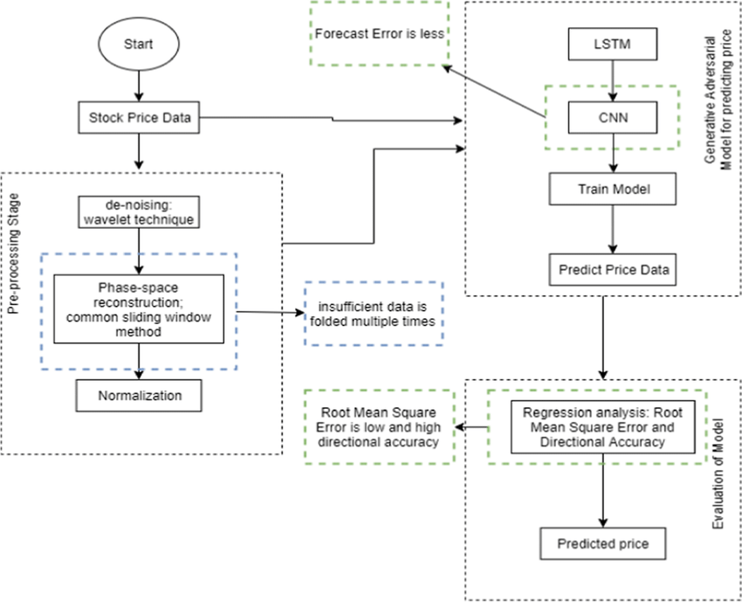

**Block diagram:**

